Method 1 :-

Up-Sampling x and y coordinates along with temperature of z = 0 plane to match the number of data points of 2d plane that is 347755 indexes by using IDW interpolation then plotting the graph side by side for comparison. Time taken is much less compare to other processes.

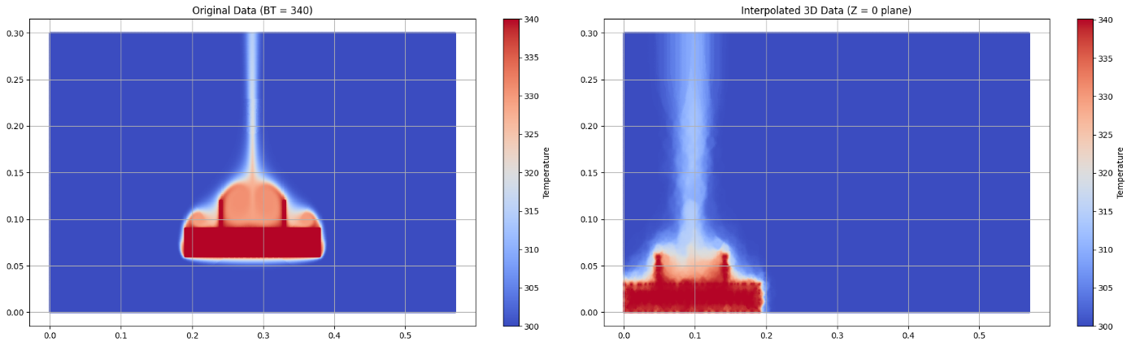

Method 2 :-

Using K-Means classifier with grouping and cluster, down-sampling the 2d data points i.e. 347755 points to match the number of 3d data points i.e. 4799 indexes and then plotting the graph. For this, using K-Means classifier time taken is around 30 minutes.

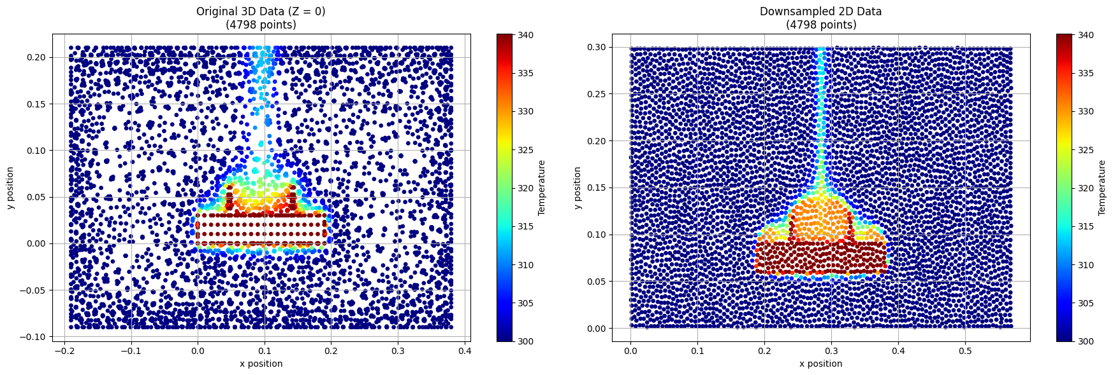

The 3d data points look like this due to non-uniform spacing and points while due to huge number of data points the 2d data points became uniform in spacing.

I have over come this by using IDW again on 3d data points to match the x and y coordinates of down-sampled 2d data points that is 3799 indexes. After that following graph has been obtained.

